TUGAS PRAKTIKUM 24
POINTER 1

Nama : Devafilla Rizqy Santosa
Kelas : 1 D4 Teknik Informatika A
NRP : 3120600026
- Tugas Pendahuluan.
  - A. Listing
main()
{
int y, x = 87;
int *px;
px = &x;
y = *px;
printf("Alamat x = %p\n", &x);
printf("Isi px = %p\n", px);
printf("Isi x = %d\n", x);
printf("Nilai yang ditunjuk oleh px = %d\n", *px);
printf("Nilai y = %d\n", y);
}
Variabel | Alamat | Nilai
x | 0060FEF8 | 87
px | 0060FEF4 | 0060FEF8
y | 0060FEFC | 87

- Output
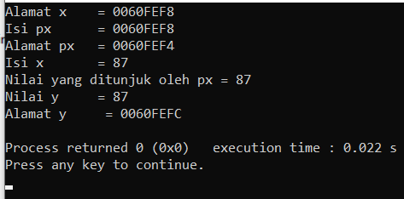
.

  - A. Listing
main()
{
float *pu, nu;
double u = 1234.0;
pu = &u;
nu = *pu;
printf("Alamat dari u = %p\n", &u);
printf("Isi pu = %p\n", pu);
printf("Isi u = %lf\n", u);
printf("Nilai yang ditunjuk oleh pu = %f\n", *pu);
printf("Nilai nu = %f\n", nu);
}

Variabel | Alamat | Nilai
u | 0060FEF0 | 1234.0
pu | 0060FEFC | 0060FEF0
nu | 0060FEF8 | 0.0000

- Output

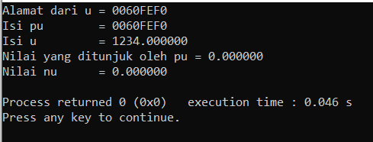

  - A.Listing
main()
{
float d = 54.5f, *pd;
printf("Isi d mula-mula = %g\n", d);
pd = &d;
*pd += 10;
printf("Isi d sekarang = %g\n", d);
}

Variabel | Alamat | Nilai
d | 0060FEFC | 54.5 64.5
pd | 0060FEF8 | 0060FEFC

B.Output
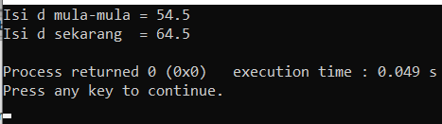

  - Listing
main()
{
int z = 20, s = 30, *pz, *ps;
pz = &z;
ps = &s;
*pz += *ps;
printf("z = %d\n", z);
printf("s = %d\n", s);
}

Variabel | Alamat | Nilai
z | 0060FEFC | 20 50
s | 0060FEF8 | 30
pz | 0060FEF4 | 0060FEFC
ps | 0060FEF0 | 0060FEF8

B.Output
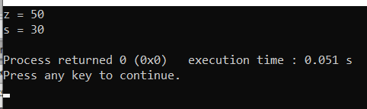
  - Listing
main()
{
char c = 'Q', *cp = &c;
printf("%c %c\n", c, *cp);
c = '/';
printf("%c %c\n", c, *cp);
*cp = '(';
printf("%c %c\n", c, *cp);
}

Variabel | Alamat | Nilai
c | 0060FEFF | Q / (
cp | 0060FEF8 | 0060FEFF

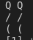

B.Analisa
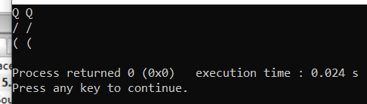

  - Listing
main()
{
int x = 1, y = 2, *ip;
ip = &x;
y = *ip;
*ip = 3;
printf(“x = %d, y = %d”, x, y);
}

Variabel | Alamat | Nilai
x | 0060FEFC | 1 3
y | 0060FEF8 | 2 1
ip | 0060FEF4 | 0060FEFC

B.Output
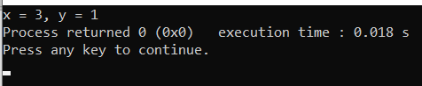

  - Listing
main()
{
int i1, i2, *p1, *p2;
i1 = 9;
p1 = &i1;
i2 = *p1 / 2 – 2 * 3;
p2 = p1;
printf("i1=%d,i2=%d,*p1=%d,*p2=%d\n",i1,i2,*p1,*p2);
}

Variabel | Alamat | Isi
i1 | 0060FEFC | 9
i2 | 0060FEF8 | -2
p1 | 0060FEF4 | 0060FEFC
p2 | 0060FEF0 | 0060FEFC

B. Output
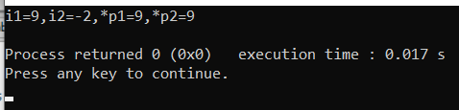

  - Listing
main()
{
int count = 10, *temp, sum = 7;
temp = &count;
*temp = 32;
temp = &sum;
*temp = count;
sum = *temp * 4;
printf("count=%d, *temp=%d, sum=%d\n", count,*temp, sum );
}

Variabel | Alamat | Nilai
count | 0060FEFC | 10 32
temp | 0060FEF8 | 0060FEFC  0060FEF4
sum | 0060FEF4 | 7 32 128

B. Output
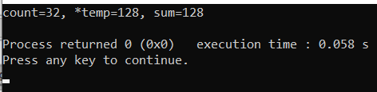

  - Listing
main()
{
int count = 13, sum = 9, *x, *y;
x = &count;
*x = 27;
y = x;
x = &sum;
*x = count;
sum = *x / 2 * 3;
printf(“count=%d, sum=%d, *x=%d, *y=%d\n”, count,sum,*x,*y);
}

Variabel | Alamat | Nilai
count | 0060FEFC | 13 27
sum | 0060FEF8 | 9 27 39
x | 0060FEF4 | 0060FEFC  0060FEF8
y | 0060FEF0 | 0060FEFC

B. Output
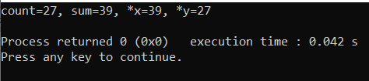

  - Listing
int r, q = 7;
int go_crazy(int *, int *);

main()
{
int *ptr1 = &q;
int *ptr2 = &q;
r = go_crazy(ptr1, ptr2);
printf("q=%d, r=%d, *ptr1=%d,*ptr2=%d\n",q,r,*ptr1,*ptr2);
ptr2 = &r;
go_crazy(ptr2, ptr1);
printf("q=%d, r=%d, *ptr1=%d, *ptr2=%d\n",q,r,*ptr1,*ptr2);
}

int go_crazy(int *p1, int *p2)
{
int x = 5;
r = 12;
*p2 = *p1 * 2;
p1 = &x;
return *p1 * 3;
}

Variabel | Alamat | Nilai
r | 00405050 | 12 15 12
q | 00402000 | 7 14 24
x | 0060FEBC | 5
ptr1 | 0060FEFC | 00402000
ptr2 | 0060FEF8 | 00402000  00405050
p1 | 0060FED0 | 00402000  0060FEBC  00405050  0060FEBC
p2 | 0060FED4 | 00402000

B. Output
